**Project Log**

**Date:30/10/2024**

**Problem statement 11 assigned by Keshav**

**Scenario:**

In large organizations, the Learning and Development (L&D) team plays a crucial role in upskilling employees, ensuring compliance with training requirements, and fostering a culture of continuous learning. However, managing multiple training programs, tracking employee progress, and ensuring the relevance of content across diverse roles can be challenging. L&D teams often struggle with coordinating training schedules, personalizing learning paths, and gathering feedback to improve future programs. Additionally, with remote and hybrid work models becoming more prevalent, traditional in-person training methods are less feasible, requiring a shift to digital solutions.

**Team Members:**

|  |  |  |  |
| --- | --- | --- | --- |
| **Group** | **Learner 1** | **Learner 2** | **Capstone Project Number** |
| 11 | Nitya N Hegde | Manuvidya | 11 |

**Date:01/11/2024**

**Abstract: GrowthPath**

GrowthPath is a comprehensive Learning and Development (L&D) platform tailored to meet the training needs of modern organizations. With a scalable microservices architecture, GrowthPath enables organizations to provide secure access, personalized training management, and insightful feedback collection, all designed to foster continuous learning. Using .NET Core Web API and Angular, the platform streamlines essential components—UserAuthAPI, TrainingManagementAPI, and FeedbackAPI—to ensure ease of use, flexibility, and data-driven improvement.

This architecture enables reduced complexity and enhanced modularity. GrowthPath integrates public APIs for content delivery and analytics, creating a dynamic, engaging, and adaptable platform that supports employee growth and enhances overall performance.

**Microservice Overview**

**UserAuthAPI**

Functionality: Securely handles user authentication, profile management, and access control.

**Authentication & Authorization**: Provides a secure login system with JWT-based authentication, ensuring only authorized users access the platform.

Role Management: Assigns and manages user roles (e.g., employee, administrator) for controlled access to various training resources and administrative functions.

Profile Management: Manages user profiles, allowing updates to user information while enforcing access permissions.

**TrainingManagementAPI**

Functionality: Centralizes training program management, scheduling, and progress tracking.

Training Program Management: Supports creation, modification, and deletion of training sessions, allowing administrators to upload materials and define schedules.

Content Integration: Leverages public content APIs to seamlessly integrate external training resources, providing users with a variety of learning materials.

Progress Tracking: Monitors and records user engagement and completion rates, enabling organizations to assess training effectiveness and ensure compliance.

Scheduling & Notifications: Facilitates the scheduling of sessions and automated notifications to remind users of upcoming or pending trainings.

**FeedbackAPI**

Functionality: Collects and evaluates participant feedback for ongoing training enhancement.

Feedback Collection: Gathers user feedback post-training via customizable surveys to assess satisfaction and training quality.

Analytics & Reporting: Aggregates feedback data to generate comprehensive reports, providing administrators with insights into areas for improvement.

Public API Integration: Uses analytics APIs to gain deeper insights into engagement metrics and further refine the training experience.

**Conclusion**

GrowthPath’s microservices-based design allows it to efficiently support organizations in managing employee training, monitoring progress, and collecting actionable feedback. By consolidating these functions into specialized services, GrowthPath provides a robust, scalable, and adaptable L&D platform that encourages continuous employee development and enables companies to stay competitive in an evolving workplace.

**Date:04/11/2024**

**Agenda:**

* To modify the previous abstract as per the guidance of Ranjan Sir
* Some research about public API
* Architecture diagram designing

In the modern workplace, effective Learning and Development (L&D) is key to fostering a culture of continuous improvement, compliance, and skill enhancement. This project introduces a scalable L&D platform leveraging a microservices-based architecture with APIs dedicated to Authentication (AuthAPI), User Management, Learning and Development (L&D API), and Feedback (FeedbackAPI). Built with .NET Core for the backend and Angular for the frontend, the platform provides an efficient, secure, and user-centric solution that addresses the unique challenges of managing employee training, progress tracking, and feedback collection.

**Functionalities**

1. **AuthAPI**:  
   Provides secure authentication and authorization through JWT-based token management, ensuring users have safe access. It handles user login, registration, password management, and role-based access control, enabling secure operations and sensitive data protection.
2. **L&DAPI**:  
   Facilitates the creation, organization, and tracking of training programs. It provides functionality for course management, scheduling, and progress tracking, offering administrators insights into user progress and training completion. External resources and public APIs may also be leveraged here to enrich course content.
3. **FeedbackAPI**:  
   Collects and analyses participant feedback through surveys and evaluations after each training session. This API allows for feedback aggregation, making it easy for administrators to assess training quality and adjust content to improve future sessions.

This microservices-driven architecture enhances flexibility, scalability, and ease of maintenance, equipping organizations to engage and develop their workforce effectively in a competitive, evolving landscape.

**Some recommended public API’s are:**

* **Coursera API**
* EdX API
* YouTube Data API

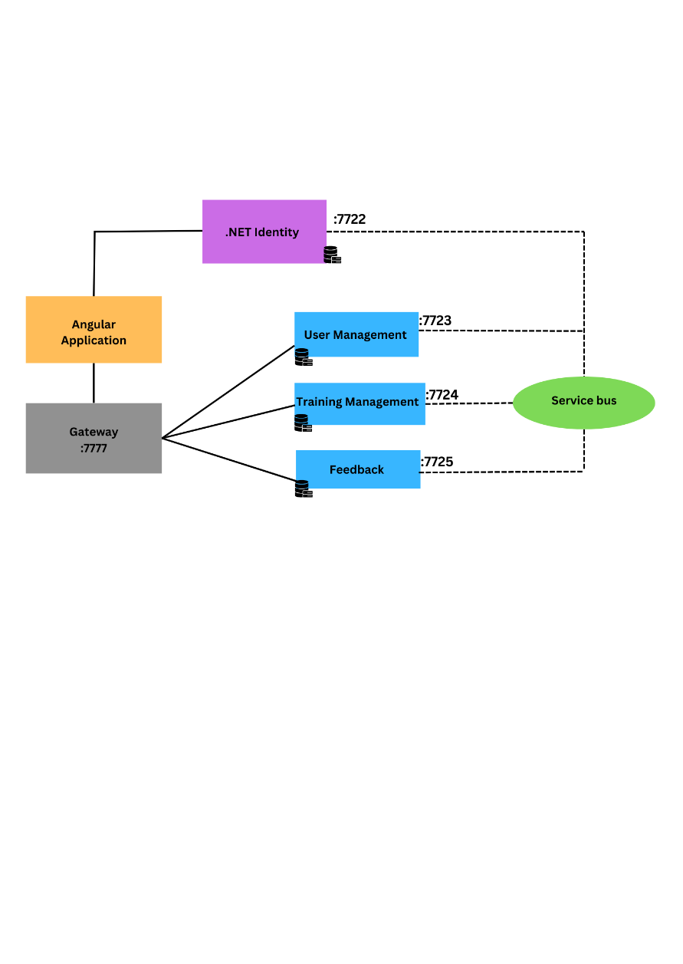

**Database Count**

1. Auth Database: 1 database for managing authentication and authorization.
2. L&D Database: 1 database to store information about courses, training modules.
3. Feedback Database: 1 database to store feedback, ratings, and survey responses.

**Total Databases**: 3

**Date:05/11/2024**

**Agenda:**

* To design class diagram

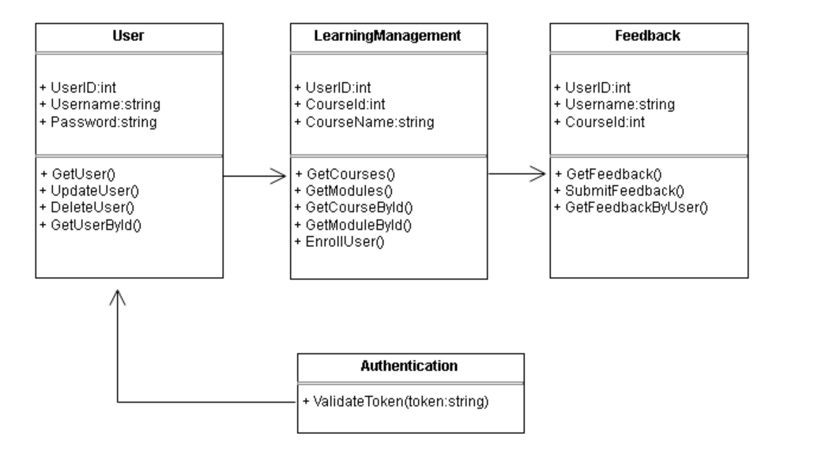

Designed prototype model which contains registration page, login page, L&D page which is linked to feedback, user profile.

User profile contains user details and course details.

**Date:06/11/2024**

**Agenda:**

* To design prototype
* To modify class diagram
* To modify architectural diagram

**Date:07/11/2024**

**Agenda:**

* To modify class diagram
* To modify architectural diagram

**Final Class diagram**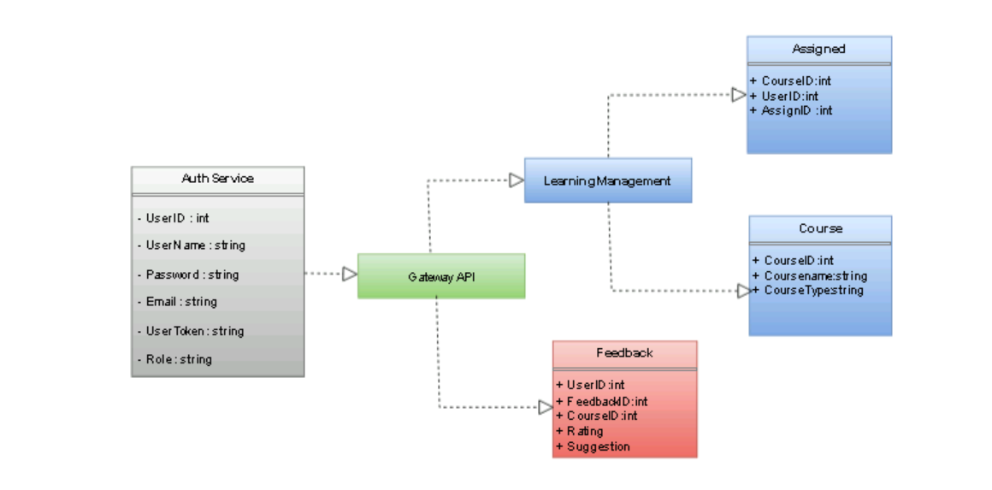

**Architectural Diagram**

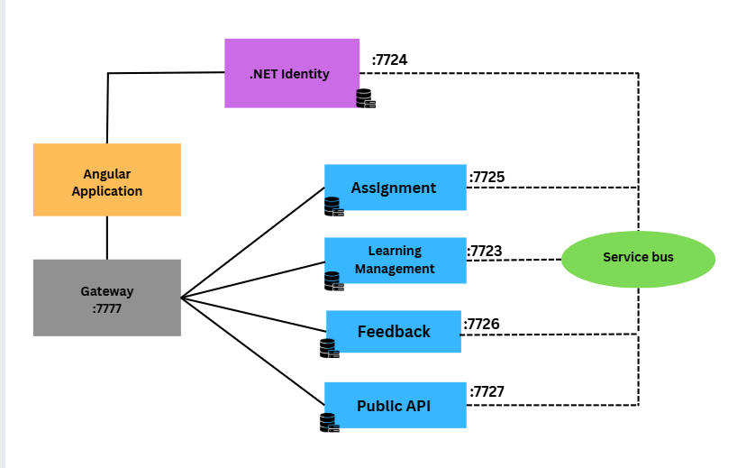

**Date:08/11/2024**

**Agenda:**

* To design Flowchart
* To start Implementation

**Flowchart**

